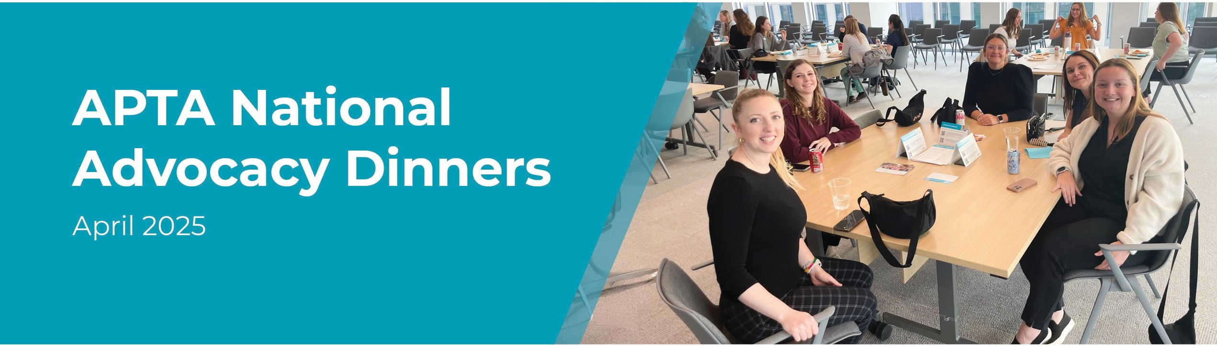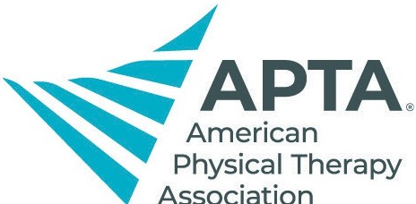

{Insert local info here}

**Learn the top legislative issues affecting your future profession and patients, and find out how YOU can get involved and make a difference NOW as a student advocate.**

National Advocacy Dinners are an annual event, usually held locally by programs and student groups, to learn about the importance of APTA advocacy and how students can get involved and stay involved throughout their careers. Check with your individual program for local event details. APTA membership is not required to attend.

**Questions?**

**Email** [**advocacy@apta.org**](mailto:advocacy@apta.org)